# Experiment No. : 4

**Title : SAC & DAC Operations**

**Date : 21 September 2021**

**Name : Shaunak Deshpande**

**Roll no : 39**

**Gr. No. : 11911180**

1. **Operating SAC using 2/2 and 3/2 DCV**

For operating SAC, we use 3/2   
DCV.

* 3/2 DCV has three ports namely inlet port “P”, exhaust port “T” and cylinder port “A”.
* It has two positions of its spool.
* In first position of spool of 3/2 DCV, fluid flows from P – A and T is closed. Hence the piston of SAC extends.
* In second position of spool of 3/2 DVC, fluid flows from A – T and P is closed. Hence the piston of SAC retracts

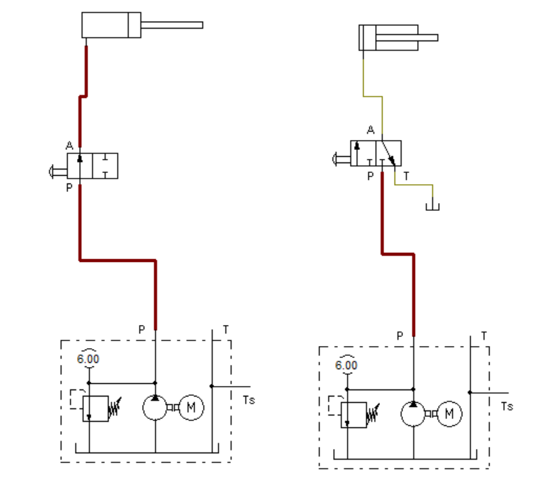

1. **Operating DAC using 4/2 DCV**

* 4/2 DCV has four ports namely inlet port “P”, exhaust port “T”, cylinder port “A” and cylinder port“B”.
* It has two positions of its spool.In first position of spool of 4/2 DCV, air flows from P – A and B – T. Hence the piston of DAC extends
* In second position spool of 4/2 DVC, air flows from P – B and A –T. Hence the piston of DAC retracts

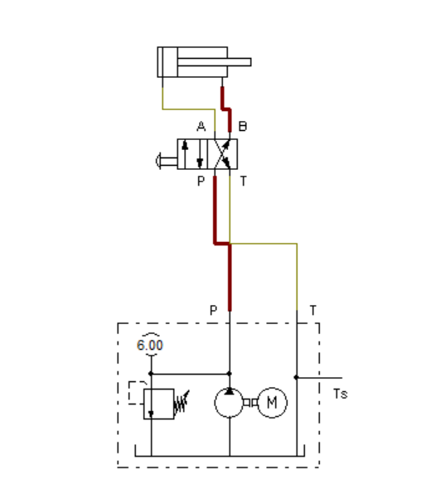

* **Two hand operation of SAC using Two 3/2 DCV**
* Actually, one 3/2 DCV is sufficient just to operate a SAC. But for safety of operator’s hands, the safety circuit consists of two 3/2 valves.
* Operator has to operate both of these valves together, then only the DAC extends.
* The circuit contains two NC 3/2 valves. NC means, “normally closed”.
* In normal position, the inlet port “P” is closed and cylinder port “A” is connected to exhaust port “T”.
* These two valves are connected in series, that is, the outlet port of first valve is connected to inlet port of second valve. When both of these valves are pressed together, fluid flows to SAC   
  and the SAC extends.

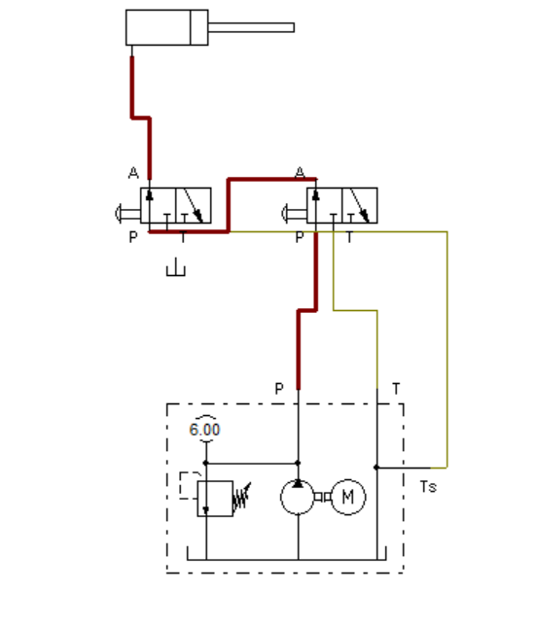

1. **Two Hand Operation of SAC using Twin Pressure valve**

* TPV has AND logic function. If fluid under pressure is supplied through both of the two inlet ports, inlet port A or inlet port B, then only there will be supply from the outlet port C.
* Circuit consists of two NC 3/2 valves, valve-1 and valve-2. The outlet of valve-1 is connected to inlet-A and that of valve-2 is connected to inlet-B.
* The outlet-C of twin pressure valve is connected to SAC.
* When both of these valves are pressed together, fluid flows to   
  SAC and the SAC extends

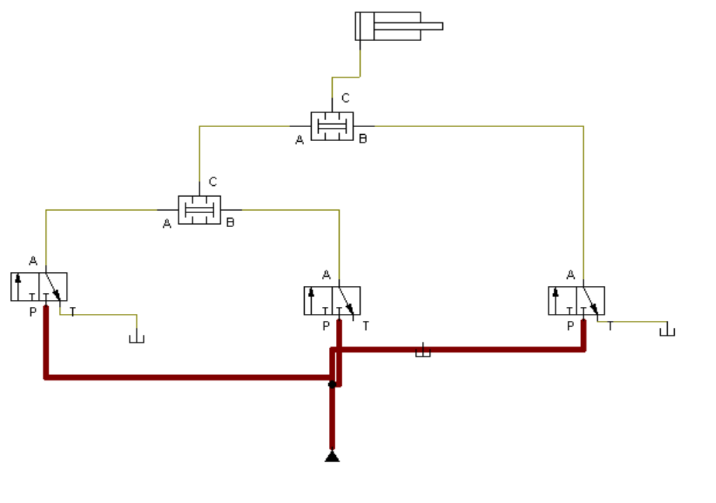

1. **Two Hand Operation of SAC using Shuttle valve**

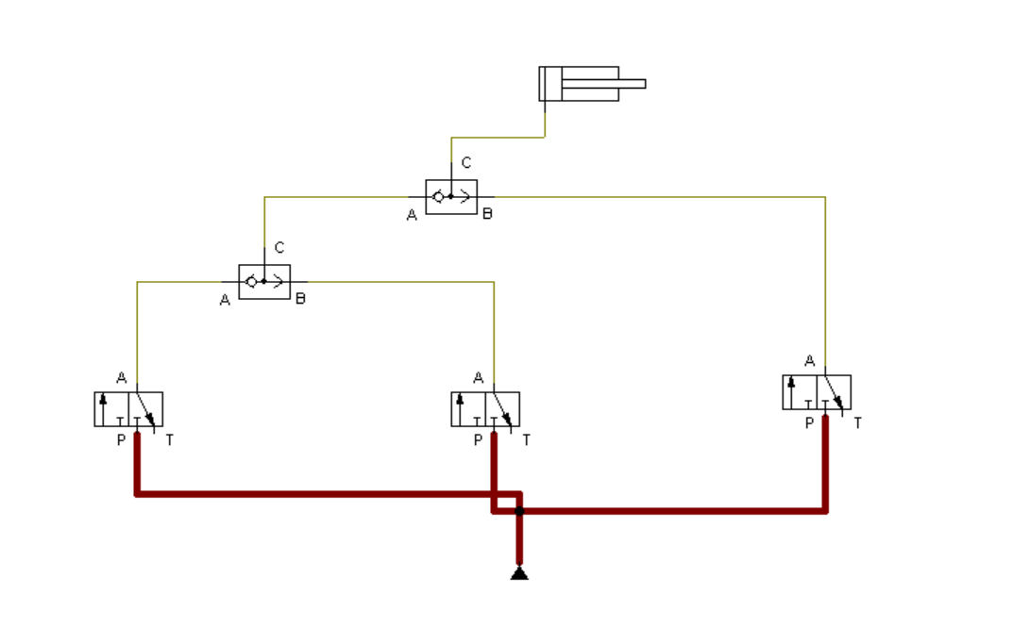

1. **Operating DAC using 4/3 DCV**

* In this example, the 4/3 DCV has closed type mid position.
* There are many different types of mid positions of 4/3 DCV, closed center, open center, tandem center, and others.
* All are having specific applications. Functioning of system should be studied and accordingly one should choose appropriate type of mid   
  position

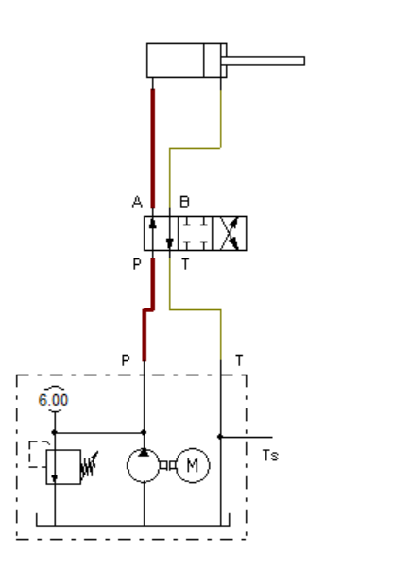

Conclusion:-

We Operated SAC using 2/2 and 3/2 DCV and DAC using 4/2 DCV.

We understood the working of Two hand operation of SAC using Two 3/2 DCV and two Hand Operation of SAC using Shuttle valve.

We learned about how to use DAC using 4/3 DCV

We also learned how to use Shuttle valves and Twin pressure valves as logic gates